Brute Force - Sorting Algorithms
Selection Sort, Bubble Sort, Insertion Sort; compare execution times
Dr.Chandravathi C

1. Selection Sort

Question 1: Trophy Ranking System
A sports event organizer has recorded the scores of 50 participants but needs to display only the top 5 scores on a leaderboard screen. Since only a few top values are needed (not a full sort), use selection sort's "find maximum repeatedly" approach to extract the top 5.

Approach
Instead of sorting the entire array, repeatedly scan the remaining unprocessed portion to find the maximum, move it to the front, and shrink the unprocessed region. Stop after 5 iterations since only the top 5 scores are required. This avoids the cost of sorting all 50 values fully.
Complexity Analysis
Aspect | Complexity | Explanation
Time | O(k × n) | Only k passes are made instead of n, each scanning the remaining n−i elements to find the max.
Space | O(1) | Sorting is done in place; only a copy of the input array is used for safety.

Test Cases
assert top_k_scores([72,88,65,90,77,95,60,83,91,68], 5) == [95,91,90,88,83]
assert top_k_scores([5,3,1], 5) == [5,3,1] # fewer than k items
assert top_k_scores([], 3) == [] # empty input
print('All test cases passed!')

Question 2: Memory-Constrained Embedded Device
A low-memory IoT sensor device collects temperature readings and must sort them with minimal write/swap operations, since each write to memory is costly on this hardware. Selection sort performs at most n−1 swaps regardless of input order, making it preferable to bubble or insertion sort here. Implement it with a swap counter to prove the claim.

Approach
Use the standard selection sort algorithm, but only perform a swap when the found minimum is not already in the correct position. Track the number of swaps performed and compare it against n−1 (the theoretical maximum) to demonstrate the low write cost.

Complexity Analysis
Aspect | Complexity | Explanation
Time | O(n²) | Two nested loops compare every pair of elements regardless of input order.
Writes | ≤ n − 1 | A swap only occurs when the minimum found is not already in place, bounding total memory writes.

Test Cases
res, sw = selection_sort_min_writes([23.5, 19.2, 25.1, 18.8, 21.4])
assert res == sorted([23.5, 19.2, 25.1, 18.8, 21.4])
assert sw <= len(res) - 1 # write bound holds
res2, sw2 = selection_sort_min_writes([1, 2, 3, 4, 5])
assert sw2 == 0 # already sorted -> zero swaps
print('All test cases passed!')

Question 3: Library Book Reordering
A librarian wants to rearrange a shelf of 20 books by ID number, but physically moving a book (swap) is time-consuming, while checking labels (comparison) is fast. Model this as an array sorting problem using selection sort and report the number of physical "moves" needed.

Approach
Represent each book as its ID in an array. Apply selection sort, incrementing a move counter only on an actual swap (a physical book relocation), while comparisons (label checks) are unrestricted since they are cheap.

Complexity Analysis
Aspect | Complexity | Explanation
Time | O(n²) | Comparisons dominate the runtime; for n = 20 this is 190 comparisons.
Physical Moves | ≤ n − 1 | Each shelf position is corrected with at most one physical swap.

Test Cases
ordered, moves = reorder_shelf([305, 102, 250, 118, 199, 400, 101])
assert ordered == sorted([305, 102, 250, 118, 199, 400, 101])
assert moves <= len(ordered) - 1
ordered2, moves2 = reorder_shelf([100, 200, 300]) # already sorted
assert moves2 == 0
print('All test cases passed!')

Question 4: Contest Prize Distribution
In a coding contest, you must repeatedly select the participant with the current highest score, print their name, remove them from the list, and repeat until all participants are ranked. Implement this using selection sort logic without using a separate sorting library.

Approach
Treat this as selection sort in descending order: for each position, scan the remaining participants to find the one with the highest score, swap them into place, and print their name as the next-ranked winner.

Complexity Analysis
Aspect | Complexity | Explanation
Time | O(n²) | Each of the n ranking positions requires a full scan of the remaining participants.
Space | O(1) extra | Ranking is produced in place using swaps; the output list just records the order.

Test Cases
ranking = distribute_prizes([('Asha',88), ('Ravi',95), ('Meera',79), ('Dev',95)])
scores_only = [p[1] for p in ranking]
assert scores_only == sorted(scores_only, reverse=True) # descending order
assert ranking[0][1] == 95 # top score first
print('All test cases passed!')

Question 5: Small Dataset in a Mobile App
A shopping app needs to sort a "recently viewed" list of just 8–10 items by price whenever the user opens the screen. Argue whether selection sort is a reasonable choice for such a small, frequently-refreshed list, and implement it with timing to support your answer.

Approach
For very small n, the O(n²) cost of selection sort is negligible in absolute terms (a handful of microseconds), and its simplicity and low swap count make it a reasonable, easy-to-maintain choice rather than pulling in a general-purpose sort for 8–10 items.

Complexity Analysis
Aspect | Complexity | Explanation
Time | O(n²), n ≤ 10 | For such small n, absolute execution time is in the microsecond range, so complexity class is not a practical concern.
Space | O(1) | In-place sort, no extra memory beyond the working copy.

Test Cases
assert selection_sort([499,129,899,45,275,60,310,150]) == sorted([499,129,899,45,275,60,310,150])
assert selection_sort([]) == [] # empty list
assert selection_sort([7]) == [7] # single item
print('All test cases passed!')

2. Bubble Sort

Question 1: Exam Result Slip Correction
A teacher has a nearly sorted list of student roll numbers (only 2–3 are out of place due to late corrections). Use optimized bubble sort (with an early-exit flag) to fix the order and show it takes very few passes.

Approach
Run bubble sort with a 'swapped' flag that tracks whether any swap occurred in a pass. If a pass completes with no swaps, the list is already sorted and the algorithm exits early — ideal for nearly sorted data like this.

Complexity Analysis
Aspect | Complexity | Explanation
Best Case | O(n) | One pass detects a fully sorted array and exits when no swaps occur.
This Scenario | ≈ O(n) | Only 2–3 misplaced roll numbers means very few passes are needed before the flag stays false.

Test Cases
sorted_rolls, passes = optimized_bubble_sort([101,102,104,103,105,107,106,108])
assert sorted_rolls == sorted([101,102,104,103,105,107,106,108])
assert passes < 8 # fewer than full n passes
sorted_ok, passes_ok = optimized_bubble_sort([1,2,3,4,5]) # already sorted
assert passes_ok == 1 # exits after first pass
print('All test cases passed!')

Question 2: Traffic Signal Priority Queue
At an intersection, vehicle priorities (ambulance > bus > car) arrive in a small queue and need constant reordering as new vehicles arrive. Simulate this using bubble sort each time a new vehicle is added, and discuss whether bubble sort's simplicity outweighs its inefficiency here.

Approach
Assign a numeric priority to each vehicle type. Whenever a vehicle joins the queue, append it and re-run bubble sort on the (small) queue to restore priority order. Since the queue is small and rarely has more than a handful of vehicles, bubble sort's O(n²) cost is negligible, and its simplicity makes it easy to reason about and verify in a safety-critical system.

Complexity Analysis
Aspect | Complexity | Explanation
Time | O(n²) | Re-sorting the whole small queue on every arrival is acceptable since n stays very small.
Trade-off | Simplicity vs. efficiency | Bubble sort is easy to verify for correctness in a safety-critical setting, which outweighs its inefficiency at this scale.

Test Cases
queue = ['car', 'car', 'bus']
queue.append('ambulance')
result = bubble_sort_queue(queue)
assert result == ['ambulance', 'bus', 'car', 'car']
assert bubble_sort_queue(['ambulance']) == ['ambulance'] # single vehicle
print('All test cases passed!')

Question 3: Bubble Sort Visualization Tool
You are building an educational tool to visually demonstrate how "bubbles" (largest elements) rise to the top with each pass. Implement bubble sort so it prints/returns the state of the array after every single pass, useful for animation.

Approach
Modify standard bubble sort so that after each outer-loop pass, the current state of the array is stored (or printed) as a frame. These frames can then be fed into an animation or step-through UI.

Complexity Analysis
Aspect | Complexity | Explanation
Time | O(n²) | Same as standard bubble sort; storing frames adds O(n) work per pass.
Space | O(n²) worst case | Up to n frames are stored, each of size n, useful for driving an animation.

Test Cases
frames = bubble_sort_with_frames([5, 1, 4, 2, 8])
assert frames[-1] == sorted([5, 1, 4, 2, 8]) # final frame is sorted
assert frames[0] == [5, 1, 4, 2, 8] # first frame is the original input
assert len(frames) >= 2 # at least an initial and final frame
print('All test cases passed!')

Question 4: Sorting Sensor Alerts by Severity
A monitoring dashboard receives 15 alerts per minute that must be sorted by severity level (1 = critical to 5 = low) for display. Use bubble sort and measure whether the early-termination optimization meaningfully improves performance on this small, frequently-updated dataset.

Approach
Implement both a plain bubble sort and an optimized version with the early-exit flag, then compare pass counts and comparisons on the same alert data to see how much the optimization helps for this small, often-partially-sorted stream.

Complexity Analysis
Aspect | Complexity | Explanation
Plain Bubble Sort | O(n²) always | Always runs the full n−1 passes regardless of how sorted the data already is.
Optimized Bubble Sort | O(n) best, O(n²) worst | Exits early once a pass makes no swaps, which helps when alerts arrive already close to sorted.

Test Cases
alerts = [2,1,3,2,1,4,3,2,5,1,2,3,4,1,2]
r1, c1 = bubble_sort_plain(alerts)
r2, c2 = bubble_sort_optimized(alerts)
assert r1 == r2 == sorted(alerts) # both produce the same sorted result
assert c2 <= c1 # optimized never does more comparisons
print('Plain comparisons:', c1, '| Optimized comparisons:', c2)
print('All test cases passed!')

Question 5: Card Game Hand Sorting
In a card game app, a player's hand of 13 cards must be sorted by rank whenever a new card is drawn. Since only one card is added at a time (nearly sorted data), implement bubble sort and compare its pass count to a full re-sort from scratch.

Approach
Use optimized bubble sort after appending the new card. Because only one card is out of place, the algorithm should need very few passes (proportional to how far the new card must travel) compared to sorting the entire hand from an unsorted state.

Complexity Analysis
Aspect | Complexity | Explanation
Nearly Sorted Hand | ≈ O(n) | Only the newly added card needs to “bubble” into place, so few passes are needed.
Fully Shuffled Hand | O(n²) | A randomly shuffled hand requires close to the maximum number of passes and swaps.

Test Cases
hand = [2, 4, 6, 8, 9, 11, 13]
hand.append(7) # nearly sorted: one new card
final_hand, passes_incremental = bubble_sort_hand(hand)
assert final_hand == sorted(hand)
import random
shuffled = hand.copy()
random.shuffle(shuffled)
_, passes_full = bubble_sort_hand(shuffled)
assert passes_incremental <= passes_full # nearly-sorted needs no more passes
print('All test cases passed!')

3. Insertion Sort

Question 1: Live Leaderboard Updates
An online game updates a leaderboard every time a single player's score changes, while the rest of the list remains sorted. Use insertion sort to insert just the updated score into its correct position instead of re-sorting the entire list, and measure the efficiency gain.

Approach
Remove the updated player's old entry, then use the insertion-sort technique of shifting elements to find and insert the new score into its correct position in the already-sorted leaderboard, avoiding a full re-sort.

Complexity Analysis
Aspect | Complexity | Explanation
Time | O(n) | Only the shift needed to place the single new score is performed, instead of an O(n log n) or O(n²) full re-sort.
Space | O(1) extra | Insertion happens via in-place shifting.

Test Cases
board = [980, 875, 760, 690, 500]
updated_board, shifts = insert_updated_score(board, 820)
assert updated_board == [980, 875, 820, 760, 690, 500]
board2, shifts2 = insert_updated_score(board, 100) # lowest score
assert board2[-1] == 100 and shifts2 == 0 # no shifts needed, goes to the end
print('All test cases passed!')

Question 2: Card Sorting While Playing
A card player sorts their hand as they pick up cards one at a time (the classic real-world analogy for insertion sort). Implement this behavior programmatically, sorting a growing hand card by card.

Approach
Maintain a hand list. Each time a new card is picked up, insert it into its correct position among the already-sorted cards by shifting larger cards one position to the right, exactly like insertion sort's inner loop.

Complexity Analysis
Aspect | Complexity | Explanation
Time | O(n) per card, O(n²) total | Each new card may require shifting past several existing cards; over n cards this totals O(n²).
Space | O(1) extra | Cards are shifted in place within the hand list.

Test Cases
hand = []
for card in [7, 2, 9, 4, 1]:
hand = pick_up_card(hand, card)
assert hand == sorted([7, 2, 9, 4, 1])
assert pick_up_card([], 5) == [5] # first card picked up
print('All test cases passed!')

Question 3: Real-Time Stock Price Feed
A trading dashboard receives stock prices one at a time and must maintain a sorted list at all times for quick min/max lookups. Use insertion sort to insert each new incoming price efficiently into the already-sorted list.

Approach
Keep a running sorted list of prices. For each incoming price, use binary search (or a linear scan) to find its correct position, then shift subsequent elements right by one and insert it — the core idea of insertion sort applied incrementally.

Complexity Analysis
Aspect | Complexity | Explanation
Time (binary search variant) | O(log n) search + O(n) shift | Finding the position is fast, but shifting array elements to make room is still O(n) per insertion.
Overall for n prices | O(n²) worst case | Still quadratic overall due to shifting, but far better than re-sorting the whole list from scratch each time.

Test Cases
prices = []
for p in [102.5, 98.3, 105.1, 100.0, 97.8]:
prices = insert_price(prices, p)
assert prices == sorted([102.5, 98.3, 105.1, 100.0, 97.8])
assert prices[0] == min(prices) and prices[-1] == max(prices) # O(1) min/max lookup
print('All test cases passed!')

Question 4: Playlist Reordering by Recently Added
A music app lets users insert a newly added song into a playlist that is already sorted by duration. Implement insertion sort logic to place just the new song correctly instead of sorting the whole playlist again.

Approach
Append the new song's duration to the playlist and shift it leftward past any longer songs until it reaches its correct sorted position, exactly as the inner loop of insertion sort does for a single new element.

Complexity Analysis
Aspect | Complexity | Explanation
Time | O(n) | Only the new song is shifted into place among already-sorted songs.
Space | O(1) extra | Insertion is performed via in-place shifting within the list.

Test Cases
playlist = [('Intro', 120), ('Chill Beat', 210), ('Long Jam', 340)]
updated_playlist = insert_song(playlist, ('Quick Track', 180))
durations = [s[1] for s in updated_playlist]
assert durations == sorted([120, 210, 340, 180])
assert ('Quick Track', 180) in updated_playlist
print('All test cases passed!')

Question 5: Nearly Sorted Sensor Log Correction
A weather station logs temperature readings in mostly chronological order, but occasional delayed transmissions cause a few entries to be out of place. Use insertion sort to fix the log and show that the number of shifts is very low compared to a randomly shuffled version of the same data.

Approach
Run standard insertion sort on the log and count total shifts performed. Because only a few entries are out of place, most elements require zero or one shift, resulting in a shift count close to the best-case O(n) rather than the worst-case O(n²).

Complexity Analysis
Aspect | Complexity | Explanation
Nearly Sorted Data | ≈ O(n) | Very few shifts are needed since most elements are already close to their correct position.
Randomly Shuffled Data | O(n²) | Requires close to the maximum number of shifts, illustrating insertion sort's sensitivity to input order.

Test Cases
log = [18.2, 18.5, 18.9, 17.9, 19.1, 19.4, 19.0]
sorted_log, shifts_nearly = insertion_sort_count_shifts(log)
assert sorted_log == sorted(log)
import random
shuffled_log = log.copy()
random.shuffle(shuffled_log)
_, shifts_random = insertion_sort_count_shifts(shuffled_log)
print('Nearly-sorted shifts:', shifts_nearly, '| Random shifts:', shifts_random)
print('All test cases passed!')

QUESTION 1:
def top_k_scores(scores, k):
arr = scores[:] # Copy the list
n = len(arr)

if k > n:
k = n

for i in range(k):
max_index = i
for j in range(i + 1, n):
if arr[j] > arr[max_index]:
max_index = j

arr[i], arr[max_index] = arr[max_index], arr[i]

return arr[:k]

# Test Cases
assert top_k_scores([72,88,65,90,77,95,60,83,91,68], 5) == [95,91,90,88,83]
assert top_k_scores([5,3,1], 5) == [5,3,1] # fewer than k items
assert top_k_scores([], 3) == [] # empty input

print("All test cases passed!")

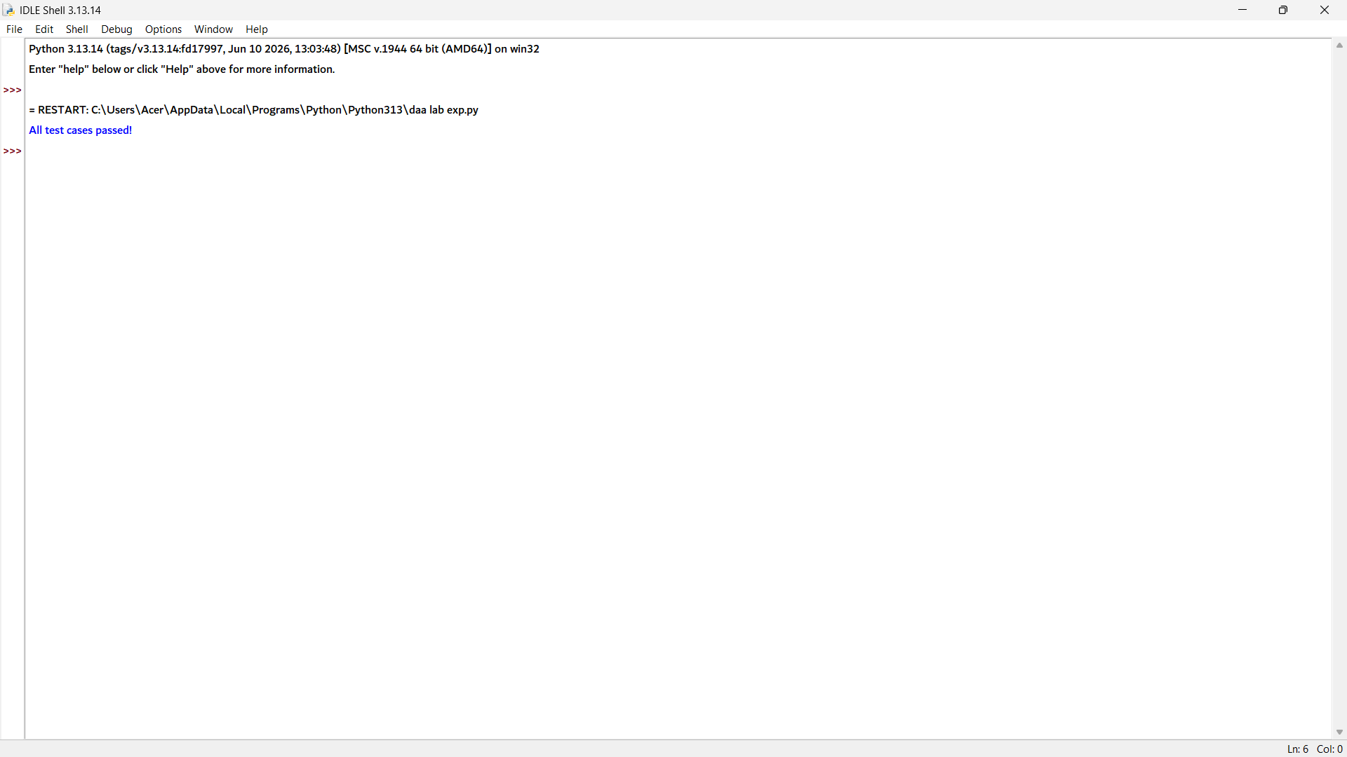

Question 2: Memory-Constrained Embedded Device

def selection_sort_min_writes(arr):
arr = arr[:] # Copy the input list
swaps = 0
n = len(arr)

for i in range(n - 1):
min_index = i

for j in range(i + 1, n):
if arr[j] < arr[min_index]:
min_index = j

if min_index != i:
arr[i], arr[min_index] = arr[min_index], arr[i]
swaps += 1

return arr, swaps

# Test Cases
res, sw = selection_sort_min_writes([23.5, 19.2, 25.1, 18.8, 21.4])
assert res == sorted([23.5, 19.2, 25.1, 18.8, 21.4])
assert sw <= len(res) - 1

res2, sw2 = selection_sort_min_writes([1, 2, 3, 4, 5])
assert sw2 == 0

print("All test cases passed!")

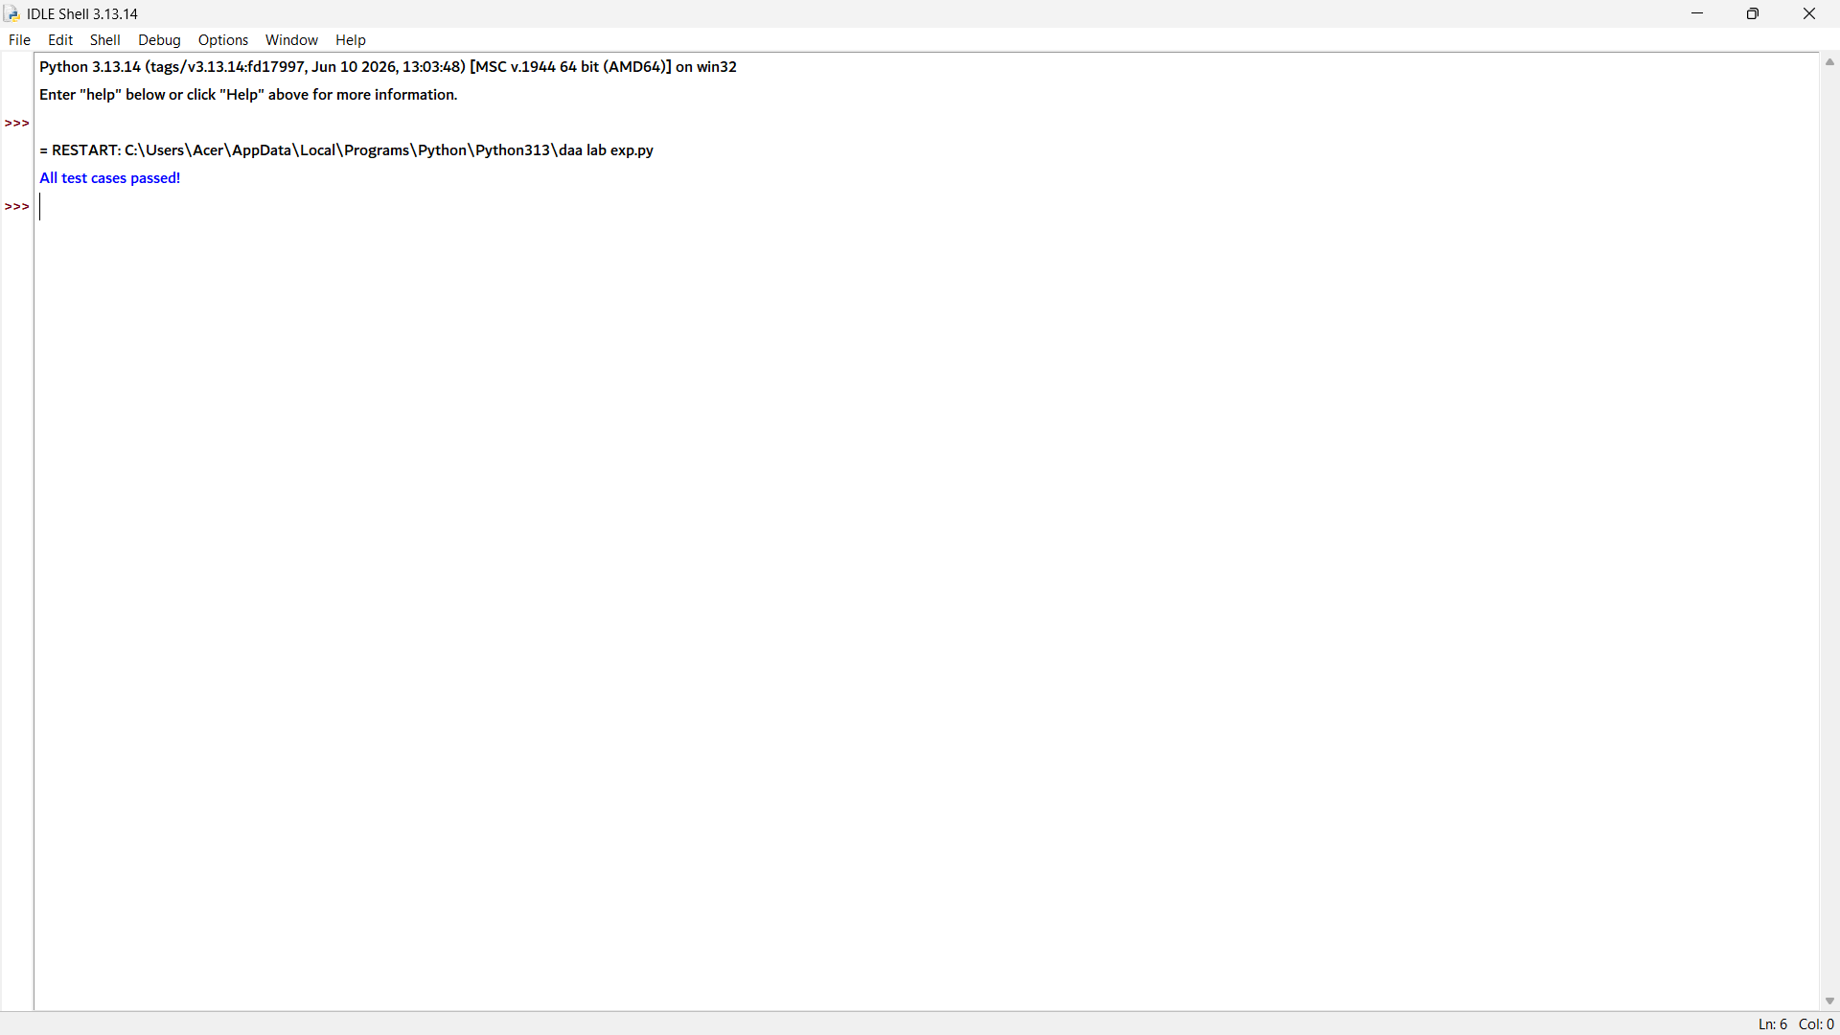

Question 3: Library Book Reordering:

def reorder_shelf(books):
books = books[:] # Copy the input list
moves = 0
n = len(books)

for i in range(n - 1):
min_index = i

for j in range(i + 1, n):
if books[j] < books[min_index]:
min_index = j

if min_index != i:
books[i], books[min_index] = books[min_index], books[i]
moves += 1

return books, moves

# Test Cases
ordered, moves = reorder_shelf([305, 102, 250, 118, 199, 400, 101])
assert ordered == sorted([305, 102, 250, 118, 199, 400, 101])
assert moves <= len(ordered) - 1

ordered2, moves2 = reorder_shelf([100, 200, 300]) # Already sorted
assert moves2 == 0

print("All test cases passed!")


Question 4: Contest Prize Distribution:

def distribute_prizes(participants):
participants = participants[:] # Copy the input list
n = len(participants)

for i in range(n - 1):
max_index = i

for j in range(i + 1, n):
if participants[j][1] > participants[max_index][1]:
max_index = j

participants[i], participants[max_index] = participants[max_index], participants[i]

return participants

# Test Cases
ranking = distribute_prizes([
('Asha', 88),
('Ravi', 95),
('Meera', 79),
('Dev', 95)
])

scores_only = [p[1] for p in ranking]

assert scores_only == sorted(scores_only, reverse=True)
assert ranking[0][1] == 95

print("Prize Distribution:")
for i, (name, score) in enumerate(ranking, 1):
print(i, "-", name, ":", score)

print("All test cases passed!")

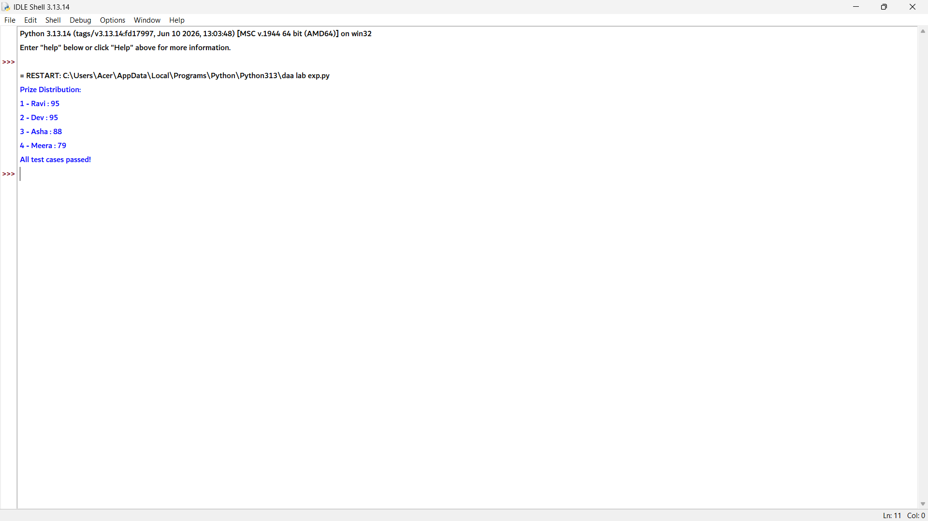

Question 5: Small Dataset in a Mobile App:

import time

def selection_sort(arr):
arr = arr[:] # Copy the input list
n = len(arr)

for i in range(n - 1):
min_index = i

for j in range(i + 1, n):
if arr[j] < arr[min_index]:
min_index = j

arr[i], arr[min_index] = arr[min_index], arr[i]

return arr

# Timing the execution
items = [499, 129, 899, 45, 275, 60, 310, 150]

start = time.perf_counter()
result = selection_sort(items)
end = time.perf_counter()

print("Sorted List:", result)
print("Execution Time:", end - start, "seconds")

# Test Cases
assert selection_sort([499,129,899,45,275,60,310,150]) == sorted([499,129,899,45,275,60,310,150])
assert selection_sort([]) == [] # Empty list
assert selection_sort([7]) == [7] # Single item

print("All test cases passed!")

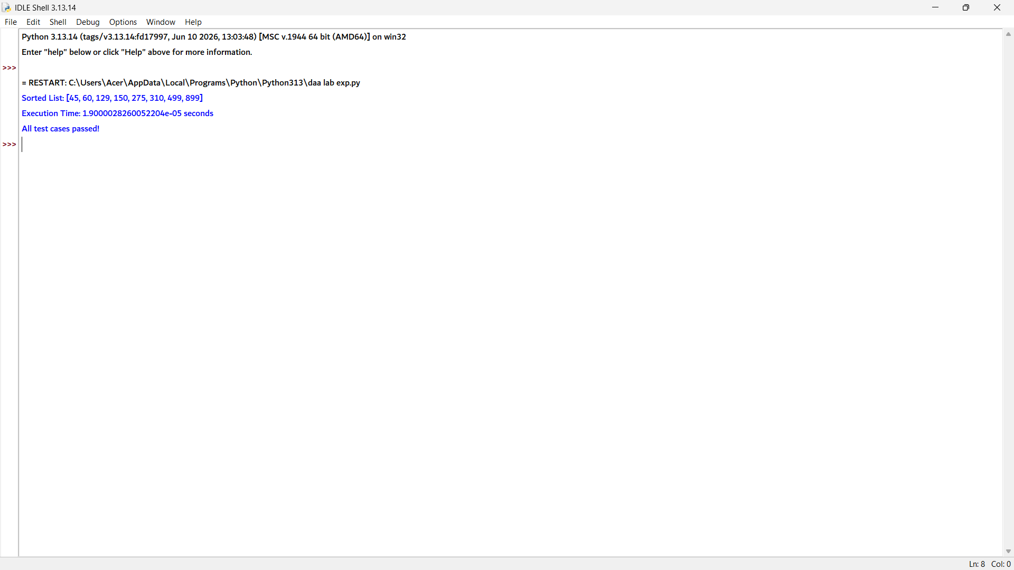

2. Bubble Sort
Question 1: Exam Result Slip Correction
def optimized_bubble_sort(arr):
arr = arr[:] # Copy the input list
n = len(arr)
passes = 0

for i in range(n - 1):
swapped = False
passes += 1

for j in range(n - 1 - i):
if arr[j] > arr[j + 1]:
arr[j], arr[j + 1] = arr[j + 1], arr[j]
swapped = True

if not swapped:
break

return arr, passes

# Test Cases
sorted_rolls, passes = optimized_bubble_sort(
[101, 102, 104, 103, 105, 107, 106, 108]
)

assert sorted_rolls == sorted([101,102,104,103,105,107,106,108])
assert passes < 8

sorted_ok, passes_ok = optimized_bubble_sort([1,2,3,4,5])
assert passes_ok == 1

print("All test cases passed!")



2. Bubble Sort – Question 2: Traffic Signal Priority Queue
Python Program
def bubble_sort_queue(queue):
queue = queue[:] # Copy the input list

priority = {
"ambulance": 3,
"bus": 2,
"car": 1
}

n = len(queue)

for i in range(n - 1):
for j in range(n - 1 - i):
if priority[queue[j]] < priority[queue[j + 1]]:
queue[j], queue[j + 1] = queue[j + 1], queue[j]

return queue

# Test Cases
queue = ['car', 'car', 'bus']
queue.append('ambulance')

result = bubble_sort_queue(queue)
assert result == ['ambulance', 'bus', 'car', 'car']

assert bubble_sort_queue(['ambulance']) == ['ambulance'] # Single vehicle

print("All test cases passed!")


Question 3: Bubble Sort Visualization Tool
def bubble_sort_with_frames(arr):
arr = arr[:] # Copy the input list
frames = [arr[:]] # Store the original array

n = len(arr)

for i in range(n - 1):
swapped = False

for j in range(n - 1 - i):
if arr[j] > arr[j + 1]:
arr[j], arr[j + 1] = arr[j + 1], arr[j]
swapped = True

frames.append(arr[:]) # Store array after each pass

if not swapped:
break

return frames

# Test Cases
frames = bubble_sort_with_frames([5, 1, 4, 2, 8])

assert frames[-1] == sorted([5, 1, 4, 2, 8]) # Final frame is sorted
assert frames[0] == [5, 1, 4, 2, 8] # First frame is original input
assert len(frames) >= 2 # Initial and final frames exist

print("Frames:")
for i, frame in enumerate(frames):
print("Pass", i, ":", frame)

print("All test cases passed!")
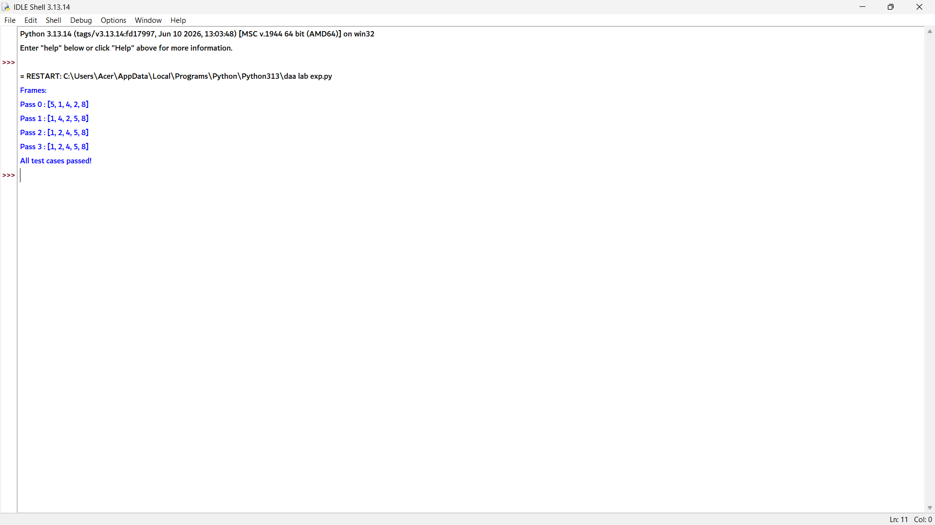

Question 4: Sorting Sensor Alerts by Severity
def bubble_sort_plain(arr):
arr = arr[:] # Copy the input list
n = len(arr)
comparisons = 0

for i in range(n - 1):
for j in range(n - 1 - i):
comparisons += 1
if arr[j] > arr[j + 1]:
arr[j], arr[j + 1] = arr[j + 1], arr[j]

return arr, comparisons

def bubble_sort_optimized(arr):
arr = arr[:] # Copy the input list
n = len(arr)
comparisons = 0

for i in range(n - 1):
swapped = False

for j in range(n - 1 - i):
comparisons += 1
if arr[j] > arr[j + 1]:
arr[j], arr[j + 1] = arr[j + 1], arr[j]
swapped = True

if not swapped:
break

return arr, comparisons

# Test Cases
alerts = [2,1,3,2,1,4,3,2,5,1,2,3,4,1,2]

r1, c1 = bubble_sort_plain(alerts)
r2, c2 = bubble_sort_optimized(alerts)

assert r1 == r2 == sorted(alerts)
assert c2 <= c1

print("Plain comparisons:", c1)
print("Optimized comparisons:", c2)
print("Sorted Alerts:", r2)
print("All test cases passed!")
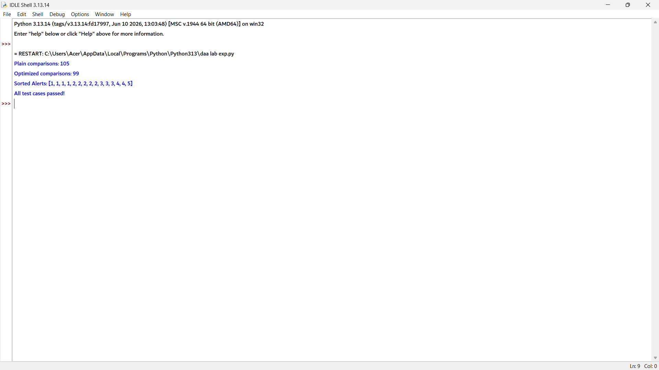
Question 5: Card Game Hand Sorting
import random

def bubble_sort_hand(hand):
hand = hand[:] # Copy the input list
n = len(hand)
passes = 0

for i in range(n - 1):
swapped = False
passes += 1

for j in range(n - 1 - i):
if hand[j] > hand[j + 1]:
hand[j], hand[j + 1] = hand[j + 1], hand[j]
swapped = True

if not swapped:
break

return hand, passes

# Test Cases
hand = [2, 4, 6, 8, 9, 11, 13]
hand.append(7) # Nearly sorted: one new card

final_hand, passes_incremental = bubble_sort_hand(hand)
assert final_hand == sorted(hand)

shuffled = hand.copy()
random.shuffle(shuffled)

_, passes_full = bubble_sort_hand(shuffled)

assert passes_incremental <= passes_full

print("Nearly Sorted Passes:", passes_incremental)
print("Fully Shuffled Passes:", passes_full)
print("All test cases passed!")
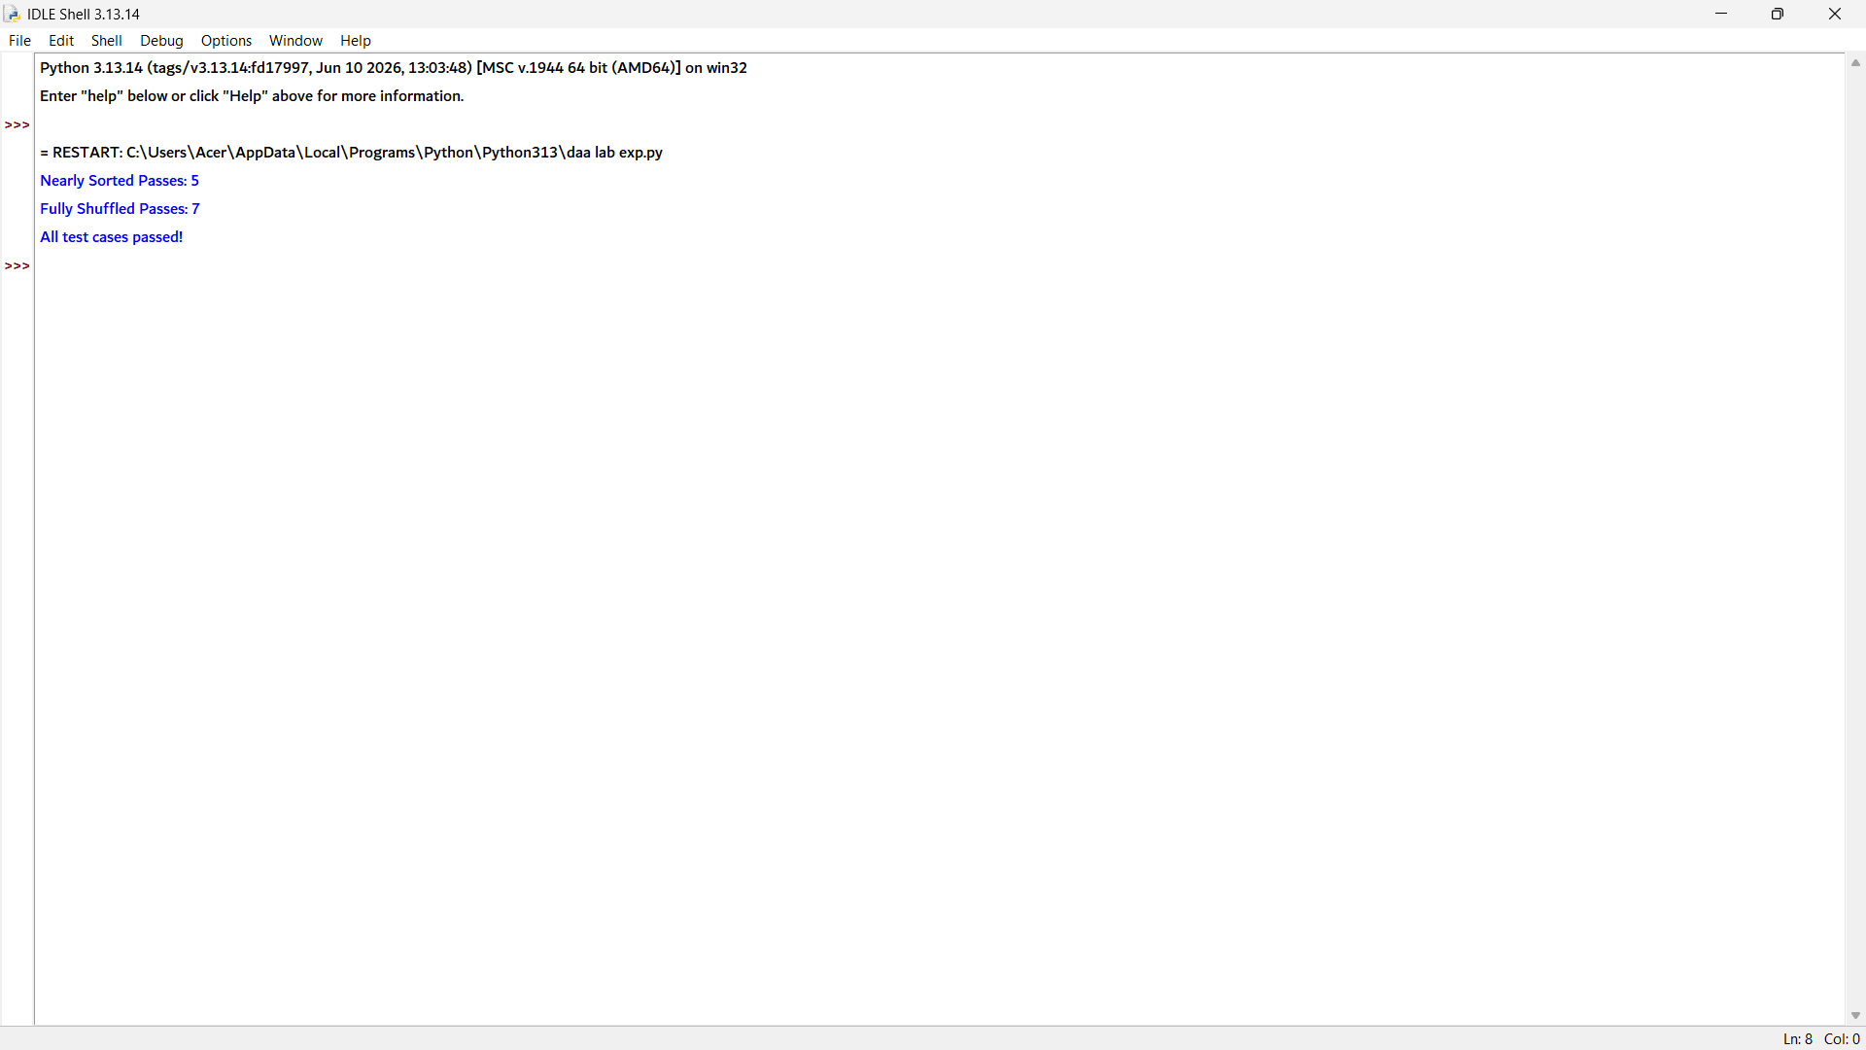

3. Insertion Sort
Question 1: Live Leaderboard Updates
def insert_updated_score(board, new_score):
board = board[:] # Copy the input list
board.append(new_score)

i = len(board) - 2
shifts = 0

# Descending order (highest score first)
while i >= 0 and board[i] < new_score:
board[i + 1] = board[i]
shifts += 1
i -= 1

board[i + 1] = new_score

return board, shifts

# Test Cases
board = [980, 875, 760, 690, 500]

updated_board, shifts = insert_updated_score(board, 820)
assert updated_board == [980, 875, 820, 760, 690, 500]

board2, shifts2 = insert_updated_score(board, 100)
assert board2[-1] == 100 and shifts2 == 0

print("All test cases passed!")



Question 2: Card Sorting While Playing

def pick_up_card(hand, card):
hand = hand[:] # Copy the current hand
hand.append(card)

i = len(hand) - 2

while i >= 0 and hand[i] > card:
hand[i + 1] = hand[i]
i -= 1

hand[i + 1] = card

return hand

# Test Cases
hand = []

for card in [7, 2, 9, 4, 1]:
hand = pick_up_card(hand, card)

assert hand == sorted([7, 2, 9, 4, 1])

assert pick_up_card([], 5) == [5] # First card picked up

print("All test cases passed!")



Question 3: Real-Time Stock Price Feed
def insert_price(prices, new_price):
prices = prices[:] # Copy the current list
prices.append(new_price)

i = len(prices) - 2

# Shift elements to insert the new price
while i >= 0 and prices[i] > new_price:
prices[i + 1] = prices[i]
i -= 1

prices[i + 1] = new_price

return prices

# Test Cases
prices = []

for p in [102.5, 98.3, 105.1, 100.0, 97.8]:
prices = insert_price(prices, p)

assert prices == sorted([102.5, 98.3, 105.1, 100.0, 97.8])
assert prices[0] == min(prices) and prices[-1] == max(prices)

print("Sorted Prices:", prices)
print("Minimum Price:", prices[0])
print("Maximum Price:", prices[-1])
print("All test cases passed!")

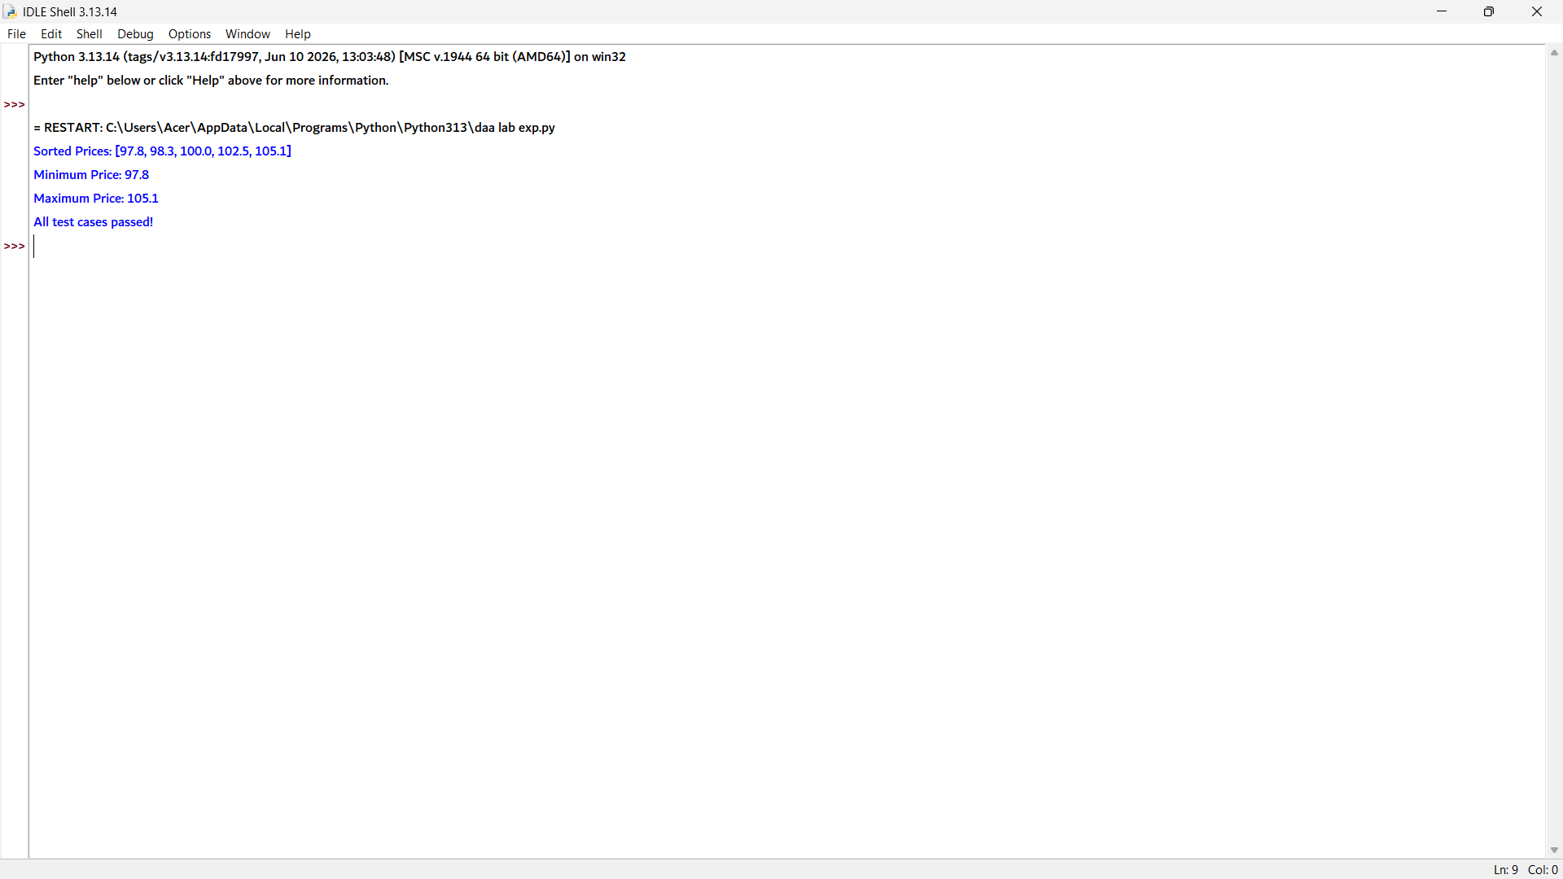

Question 4: Playlist Reordering by Recently Added

def insert_song(playlist, new_song):
playlist = playlist[:] # Copy the current playlist
playlist.append(new_song)

i = len(playlist) - 2

# Shift songs with longer duration to the right
while i >= 0 and playlist[i][1] > new_song[1]:
playlist[i + 1] = playlist[i]
i -= 1

playlist[i + 1] = new_song

return playlist

# Test Cases
playlist = [('Intro', 120), ('Chill Beat', 210), ('Long Jam', 340)]

updated_playlist = insert_song(playlist, ('Quick Track', 180))

durations = [song[1] for song in updated_playlist]

assert durations == sorted([120, 210, 340, 180])
assert ('Quick Track', 180) in updated_playlist

print("Updated Playlist:")
for song in updated_playlist:
print(song)

print("All test cases passed!")

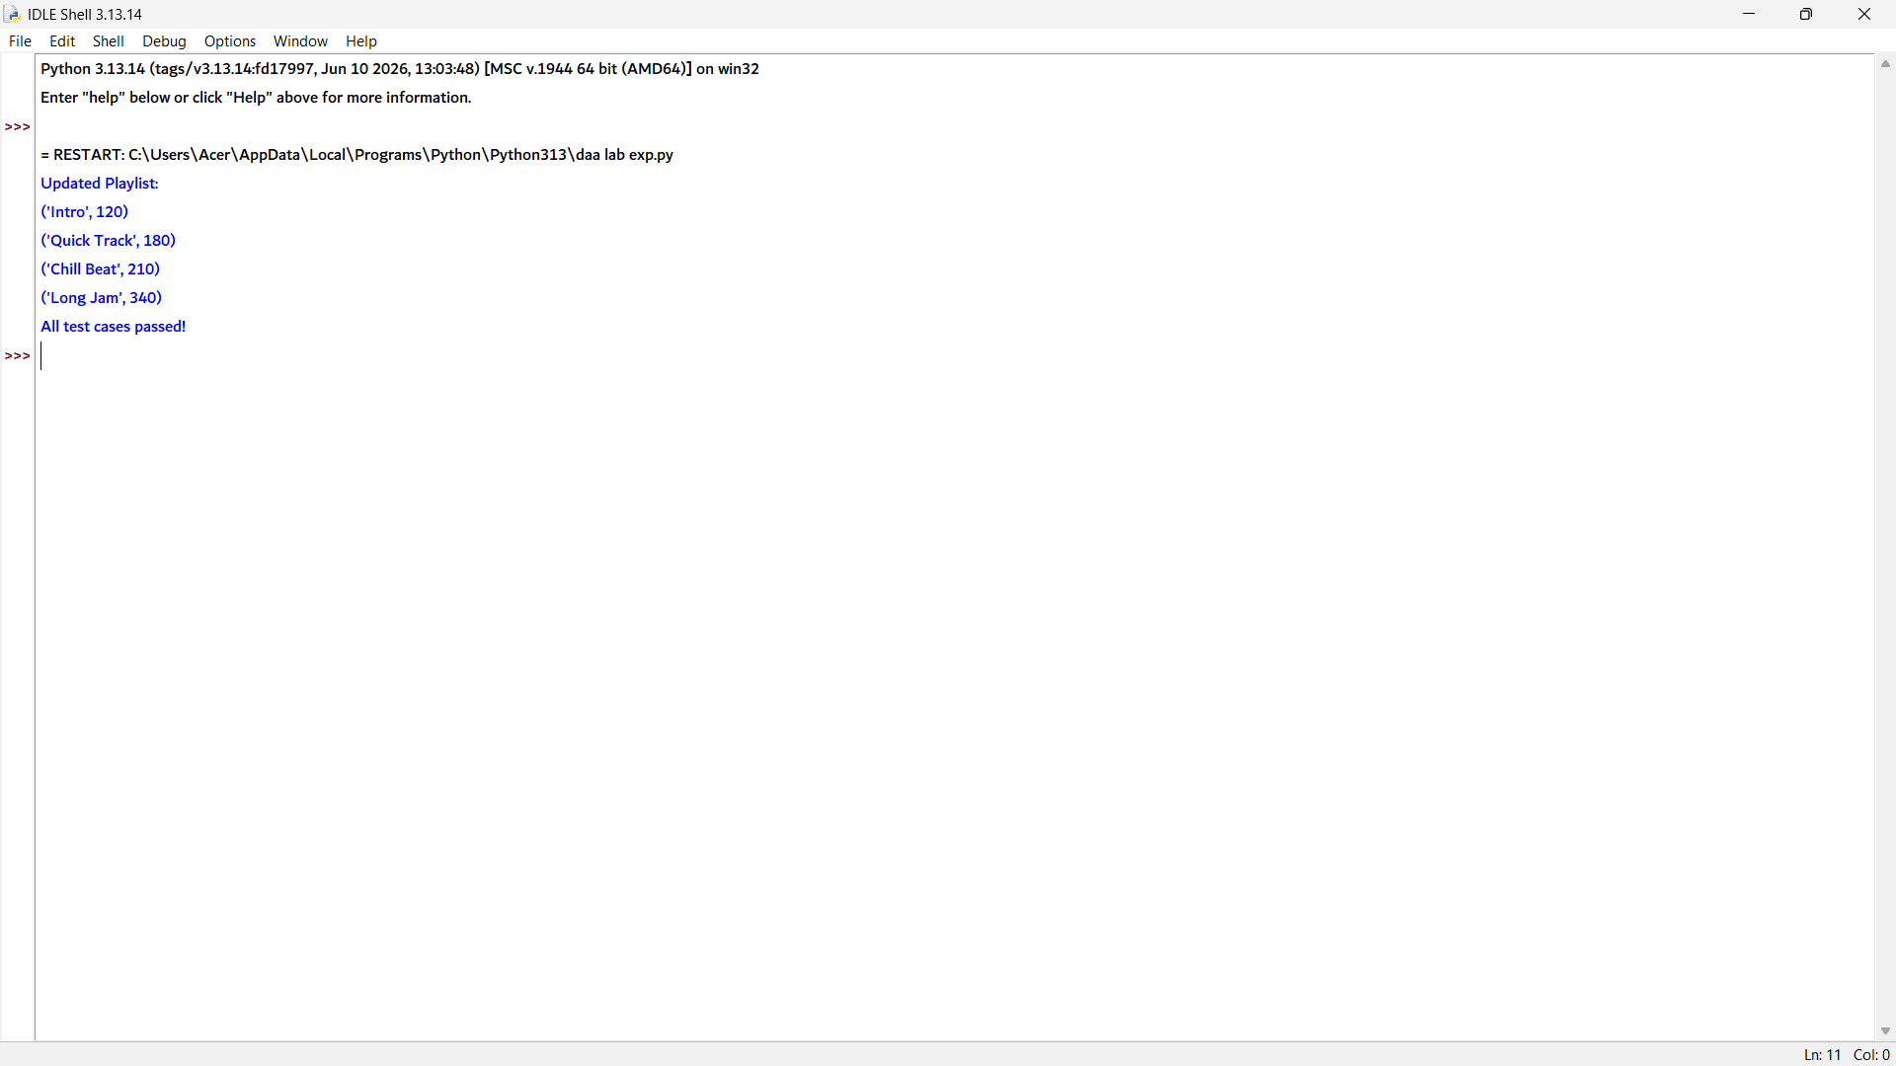

Question 5: Nearly Sorted Sensor Log Correction

import random

def insertion_sort_count_shifts(arr):
arr = arr[:] # Copy the input list
shifts = 0

for i in range(1, len(arr)):
key = arr[i]
j = i - 1

while j >= 0 and arr[j] > key:
arr[j + 1] = arr[j]
shifts += 1
j -= 1

arr[j + 1] = key

return arr, shifts

# Test Cases
log = [18.2, 18.5, 18.9, 17.9, 19.1, 19.4, 19.0]

sorted_log, shifts_nearly = insertion_sort_count_shifts(log)
assert sorted_log == sorted(log)

shuffled_log = log.copy()
random.shuffle(shuffled_log)

_, shifts_random = insertion_sort_count_shifts(shuffled_log)

print("Nearly-sorted shifts:", shifts_nearly)
print("Random shifts:", shifts_random)
print("All test cases passed!")

